# Week 8 Homework

Stefani Reinhardt

## My Kahoot Quiz Score:

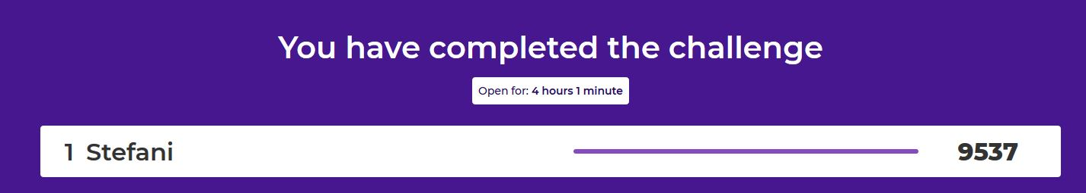

## Privacy vs. Convenience Forum Post

I just watched a documentary on Netflix called the *Social Dilemma* and it gave me a peak behind the curtain of big data. The more I learn about how companies like Google and Facebook use our data, the more I feel like I am being “watched” and that the current algorithms being used are to blame for the rise in misinformation. I think data privacy is a growing concern, but I also think there are not enough tech savvy people in some branches of government that understand how to police big tech from selling user data. In my experience after working for nearly ten years in local and state government agencies, the internet and technology in general have advanced at such a rate that it has literally surpassed the technical ability of those currently working in positions that should be policing or managing it. When you consider people who completed school before the internet went live, unless they were able to adapt to new tech advancements through their careers, they’ve had very little training on how to protect their data. I protect myself by limiting the amount of personal information I share on the internet and I don’t use Google or Facebook anymore.

## Link to my repository: https://github.com/stefanireinhardt/MART-120/tree/master/Homework_8